Aim Early Idaho Newsblast

Special Edition
  - Aim Early Idaho institute
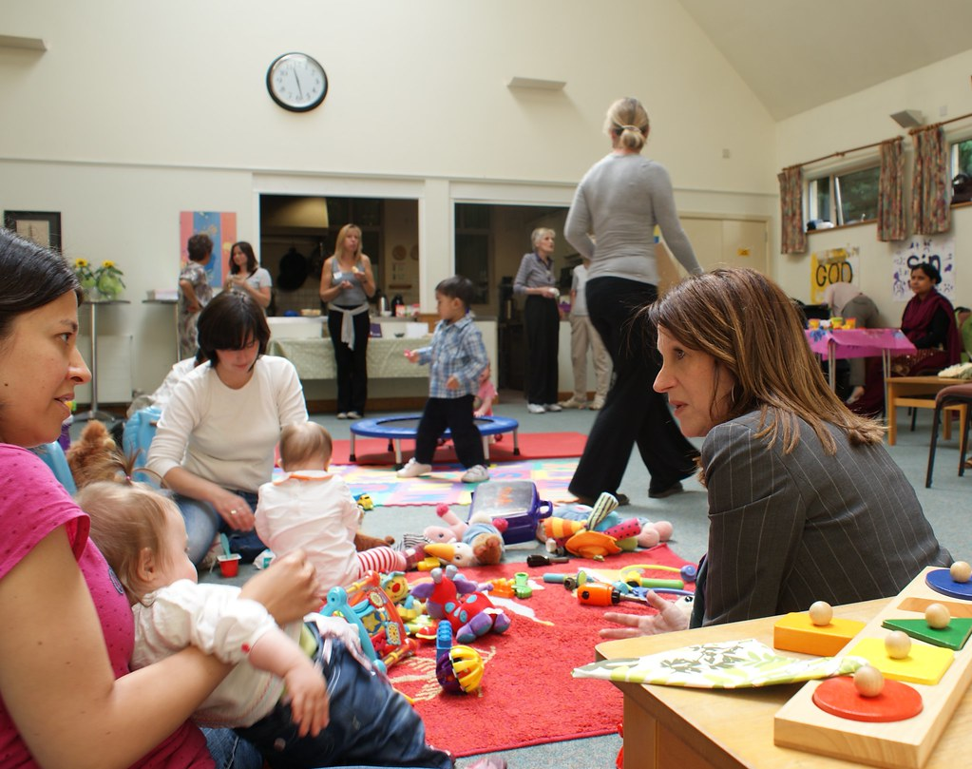
Understanding infant mental health is the key to preventing and treating the mental health problems of very young children and their families. It also helps guide the development of healthy social and emotional behaviors. Learn more about infant mental health and how important trusted relationships are for infants and children.
5th Biennial Infant Mental Health Institute featuring:  Dr. Mindy Kronenberg, PhD; a clinical psychologist in private practice in Memphis, Tennessee. She is Adjunct Clinical Professor at Louisiana State University Health Sciences Center and an affiliate member of the National Child Traumatic Stress Network. Dr. Kronenberg’s clinical and research interests include infant mental health, the assessment and treatment of trauma across the lifespan, psychological first aid, and the impact of trauma on young children.  In addition, presenting will be Leah Niezwaag, LCSW is a licensed clinical social worker endorsed at Level III in Infant and Early Childhood Mental Health. Leah has worked in Infant Mental Health in a variety of settings as a home visitor, childcare consultant, and therapist. Currently, Leah serves as one of two NEAR@Home facilitators in Idaho, who support early childhood home visiting programs in utilization of the NEAR@Home Toolkit to address Adverse Childhood Experiences (ACEs) in home visits. | Registration:  Check Eventbrite for registration details or www.aimearlyidaho.org. |  | Elections:  Aim Early Idaho is looking for women and men that have a desire to make a difference in the lives of infants and early childhood mental health to join our Board of Directors.  Current positions up for election:  President –Elect; President; Secretary; Parent Representative; Early Childhood Representative; Mental Health Representative; Health Care Representative; and Student Liaison.  Contact Phyllis Vernon for more information: vernonp@wicap.org

INFANT MENTAL HEALTH INSTITUTE AGENDA
October 29-30, 2019
Holiday Inn Boise Airport
2970 W Elder Street
Boise ID 83705

TUESDAY October 29, 2019
8:00- 8:30 Registration and Sign-in
8:30- 8:45 Welcome
Phyllis Vernon
President, Aim Early Idaho
8:45- 10:15 Keynote Address: Infant Mental Health and the Value of Relationships
Mindy Kronenberg, PhD IMH-E® Infant Mental Health Mentor-Clinical
10:15- 10:30 Stretch Break
10:30-12:00 Infant Mental Health and the Value of Relationships (continued)
Mindy Kronenberg, PhD IMH-E® Infant Mental Health Mentor-Clinical
12:00- 1:00 Lunch and Aim Early Idaho Annual Meeting
1:00- 2:30 Keynote Address: The Impact of Trauma on Infant Mental Health
Mindy Kronenberg, PhD IMH-E® Infant Mental Health Mentor-Clinical
2:30- 2:45 Stretch Break
2:45-4:00 The Impact of Trauma on Infant Mental Health (continued)
Mindy Kronenberg, PhD IMH-E® Infant Mental Health Mentor-Clinical
4:00- 4:30 Evaluation and Closing
Aim Early Idaho Board Member

INFANT MENTAL HEALTH INSTITUTE AGENDA
October 29-30, 2019
Holiday Inn Boise Airport
2970 W Elder Street
Boise ID 83705

WEDNESDAY October 30, 2019
8:00-8:30 Registration and Sign-in
8:30-10:00 Breakout Sessions (A) and (B)
A. Reflective Supervision/Consultation in Practice
Mindy Kronenberg, PhD IMH-E® Infant Mental Health Mentor-Clinical
B. Grief and Loss in Early Childhood: Multiple Perspectives
Leah Niezwaag, LCSW IMH-E® Infant Mental Health Specialist
10:00-10:15 Stretch Break
10:15-11:45 Breakout Sessions (C) and (D)
C. Reflective Supervision/Consultation in Practice
Mindy Kronenberg, PhD IMH-E® Infant Mental Health Mentor-Clinical
D. Grief and Loss in Early Childhood: Multiple Perspectives
Leah Niezwaag, LCSW IMH-E® Infant Mental Health Specialist
11:45-1:30 Networking Lunch
1:30–2:30 Keynote Address: Reflective Supervision/Consultation in Practice
Mindy Kronenberg, PhD IMH-E® Infant Mental Health Mentor-Clinical
2:30-2:45 Stretch Break
2:45-4:00 Keynote Address: Reflective Supervision/Consultation in Practice (continued)
4:00-4:30 Evaluation and Closing
Aim Early Idaho Board Member

Training Objectives

Mindy’s Presentation:
As a result of participating in this 2-day training, participants will be able to:
• Define attachment relationships
• Understand the impact of trauma and stress on relationships
• Recognize concerns in relationships
• Know how to help support infants, toddlers and caregivers impacted by stress and trauma
• Know how to take care of self
• Differentiate reflective, clinical, and administrative supervision.
• Describe characteristics/skills of the reflective supervisor and reflective supervisee.
• List 6 essential elements of reflective supervision as defined by Watson et al. (2016).

Leah’s presentation:
• Participants will begin to understand on how grief and loss appears in the caregiving relationship.

• Participants will begin to understand how grief and loss presents for young children, birth to three.

• Participants will learn infant mental health principles that will inform their work with families.

• Participants will gain understanding of infant mental health practices in joining with families.

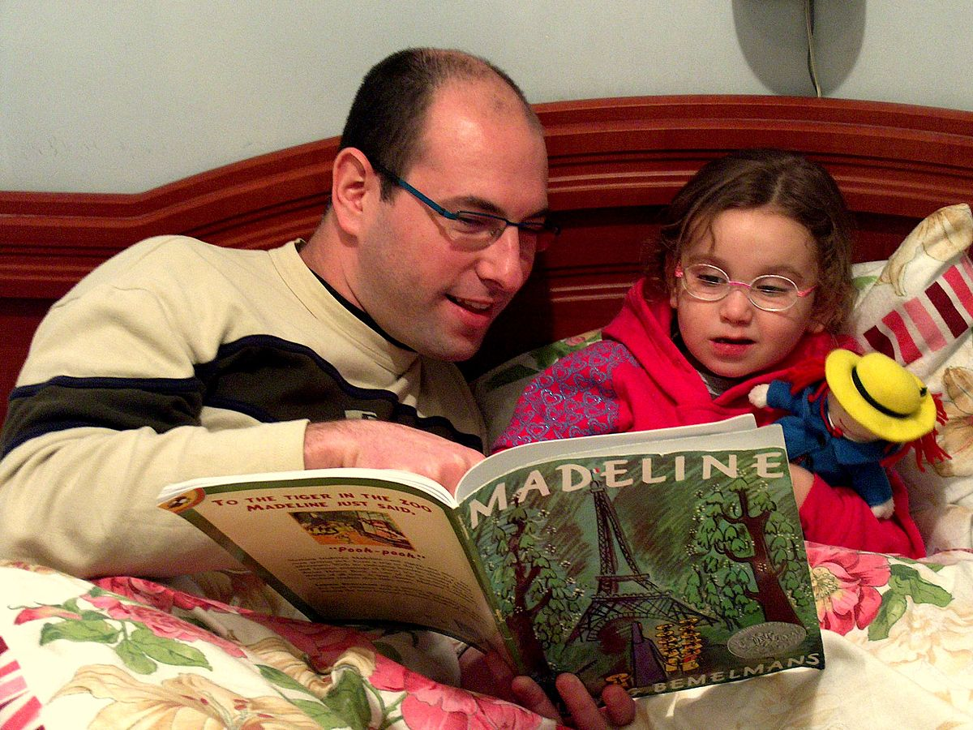
Aim Early Idaho Institute  Date: October 29th and 30th, 2019  Location: Holiday Inn Express,  2970 West Elder Street  Boise, ID 83705  208-344-7444  Block of rooms have been reserved for the Institute  Must reserve before October 7, 2019. | Vendor Tables are available.  Check out our website:  www.aimearlyidaho.org  for an application.
General Information:
- Aim Early Idaho Annual Meeting will be held during Lunch on the first day. Elections will take place at that time.
- Lunch will be provided both days.
- Vendor networking will be available during the Institute.

